

**PASHA DE CARTIER WATCH**

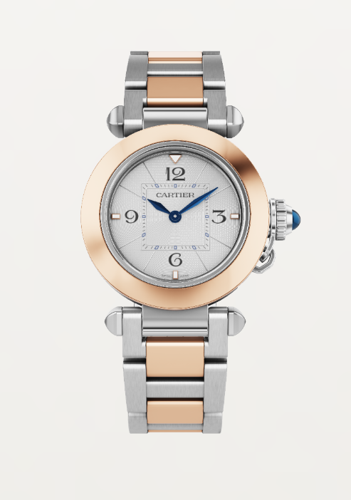

Product Details:

Pasha de Cartier watch, 30 mm, quartz movement. Steel case, 750/1000 rose gold bezel, fluted crown cap and crown set with synthetic spinels, opaline flinqué dial, blued steel diamond-shaped hands, bracelet in 750/1000 rose gold and steel, second strap in blue alligator skin, interchangeable steel folding buckle.

Both are fitted with the QuickSwitch interchangeable system. Case diameter: 30 mm, thickness: 8.22 mm. Water-resistant to 3 bar (approx. 30 metres).